Project 3
Data Discovery
It appears that this dataset is a noisy version of the MNIST fashion set. A plot of some of the images is shown below.
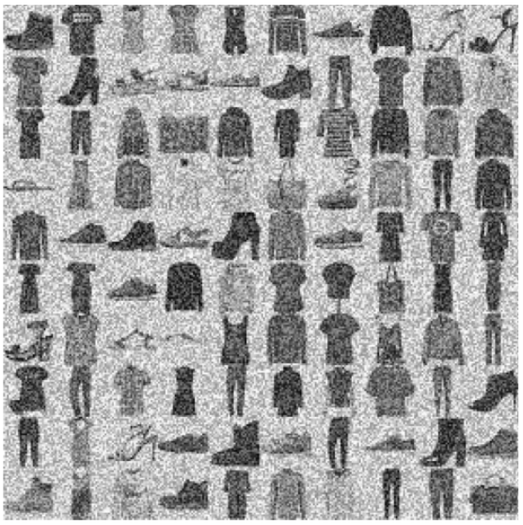
Figure 1: Project dataset.
I’d also like to mention that I had quite a bit of trouble setting up the data initially as it was not provided with a size that fit well with the architecture that the book gives. Upon reshaping the data a bit and adding explicitly a shape parameters spelling out that there is only one channel in each image, the problem was fixed.

Choosing an Architecture
The goal of this project is to create a model that has as little parameters as possible while still providing a higher accuracy. I decided that a good place to start would be with the book example of a convolutional neural network (CNN) and it has way too many parameters for the purposes of this project (a total of 1,356,138).
I then considered the idea of using a ResNet based architecture since it has shown to have a higher accuracy with less parameters while at the same time being deeper. The table below reflects the modifications that I made to the ResNet-34 architecture and how many parameters I was able shrink it to.
Table 1: Table of steps taken to reduce model parameters.
Model Modification | Total Parameters | Training Time  [1/10 epochs] (sec) | 1 Epoch Accuracy | 10 Epoch Accuracy
Original | 21,300,554 | 2378 | 73.22% | N/A
Reduce number of Res filters to (64:1, 128: 1, 256:1, 512: 1) | 4,910,410 | 600 | 80.24% | N/A
Remove 512 Res filter | 1,231,690 | 122 | 84.42% | N/A
Remove 256 Res filter | 309,834 | [55/519] | 78.35% | 91.22%
Remove 128 Res filter | 78,282 | [38/346] | 66.47% | 70.91%
Replace 128 Res filter with second 64 filter | 125,522 | [74/544] | 75.55% | 88.80%
Change all 64 size filters to 32 size | 39,402 | [31/278] | 76.31% | 87.27%
Change all filters to 16 size | 10,490 | [20/177] | 77.20% | 83.64%
Total: 5 Res blocks with size 16 | 24,698 | [35/319] | 69.95% | 87.09%
Total: 10 Res blocks with size 16 | 48,378 | [61/594] | 72.13% | 89.55%
Add Conv, Norm, Pool from initial 32 filters to 16 | 30,218 | [21/168] | 77.49% | 85.91%
After doing a lot of finagling with my model I managed to ween down the parameters to be less than 50,000. The green option in the table is the model architecture that I wound up proceeding with. Upon training it for a longer period of time, the accuracy increased further to an even greater degree even with the validation testing. The table below shows the scores garnered for this model depending on how many epochs the training ran for.
Epochs | Test Score | Validation Score
1 | 90.12% | 86.33%
5 | 98.42 | 84.43%
10 | 89.78% | 86.54%
15 | 99.33% | 84.95%
25 | 93.86% | 84.59%
50 | 95.71% | 84.28%
100 | 98.75% | 85.07

